Student’s name | …………………………………………………….…… | Grade | 3
Subject | Computer | Week No. | 14
Lesson Title | Create Graphs | Unit
Worksheet No. ( 14 ) (Answer)
Question A: Write the correct name of each part.

Entries | Axis title | Chart title
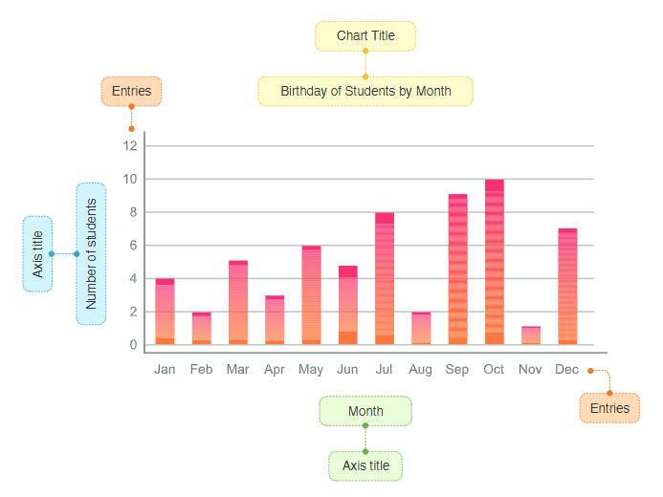

Good Luck

